C101 Programming

Assignment 1

Hand out Week Commencing: W/C 18th November 2013

Hand in Week Commencing: W/C 20th January 2014

Tasks

This document contains class templates for a simulation of a simple card game. The rules of the game are:

A player is dealt three cards, she/he should then try and maximise their points by exchanging low scoring cards for high scoring cards. A game consists of three turns. On each turn, a player must change a card.

POINTS : Points equal to the face value of each numbered card
[e.g. the five of hearts is equal to five points]
One point for an ACE
Eleven points for a Jack
Twelve points for a Queen
Thirteen points for a King

PLUS
Five extra points for two cards of the same suit
Ten extra points for three cards of the same suit

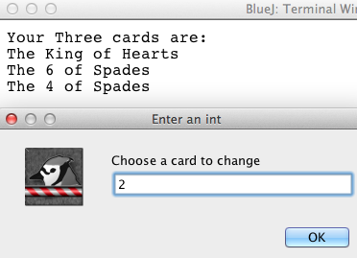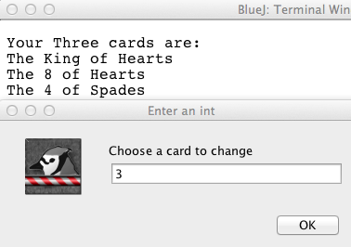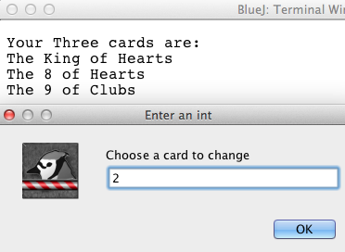

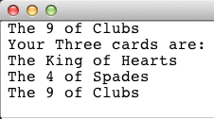

The following Class diagram describes the relationship between the class templates.

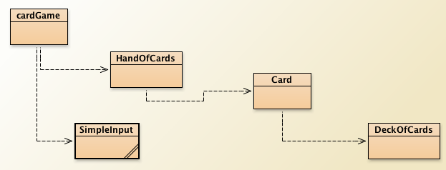

Assignment Tasks
Complete the following classes to create the game
The DeckOfCards class
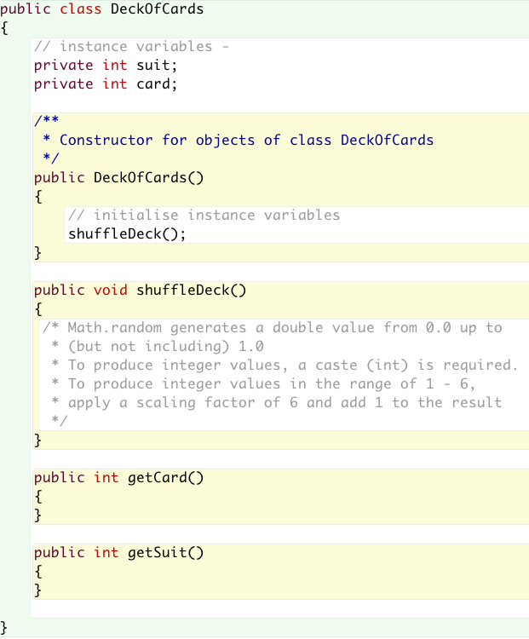

The Card class
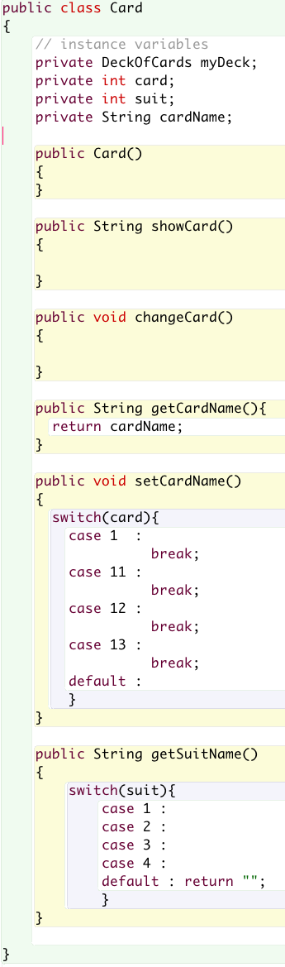

The HandOfCards class
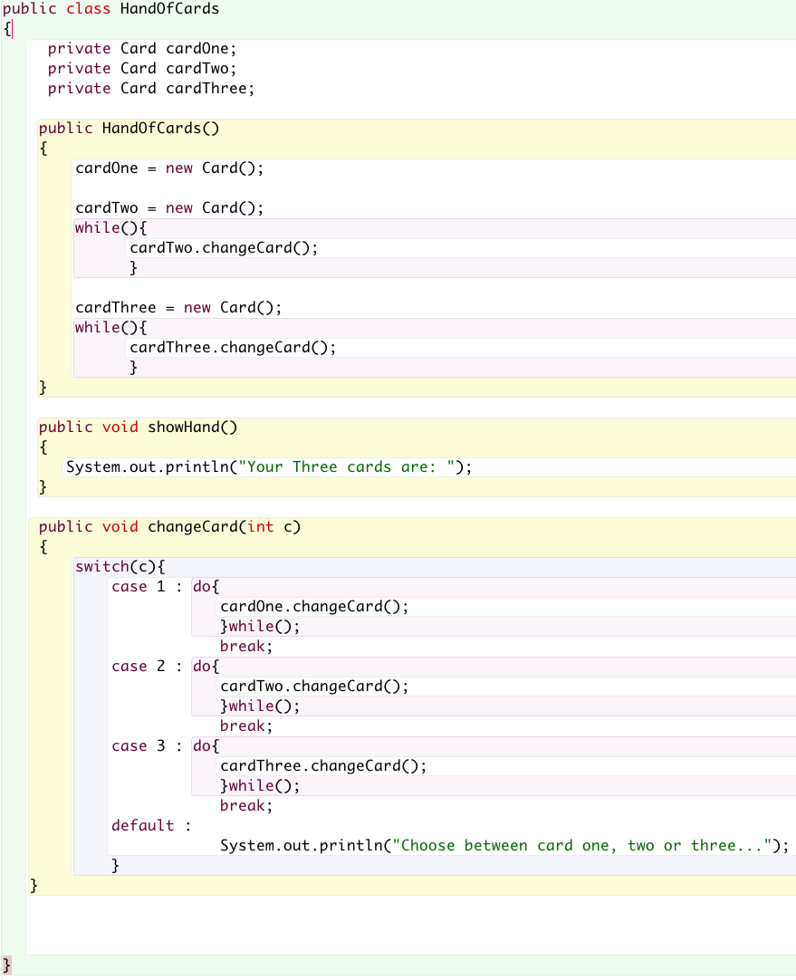
The CardGame class
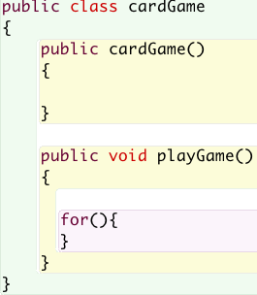
Assessment criteria

Grade F
- Work submitted, but criteria for grade E are not met.

Grade E
- Constructor added to all classes.
- Code is commented.

Grade D
- As per grade E plus.
- DeckofCards class produces random cards.
- Each class has a declared constructor.
- Required accessor and mutator methods have been added to each class
- Satisfactory demonstration of code to lecturer with Q and A session

Grade C
- As per grade D plus
- Working Card class.
- Commented code gives good level of detail.

Grade B
- As per grade C plus
- A working card game
- Score calculated and printed to screen
- Excellent level of comments

Grade A
- As per grade B plus
- Game maintains highest 3 scores with details of winning hands

